PROJECT 2: Wireshark — FTP & HTTP Traffic Analysis

PART 1 — FTP Protocol Analysis
Experiment 1 — Establish FTP Connection (Steps 1–2)
- Which port is used?
- FTP control connection uses TCP port 21.
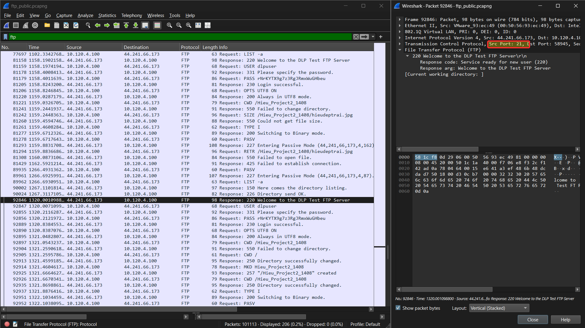
- What is the server IP?
- The FTP server IP address is 44.241.66.173.
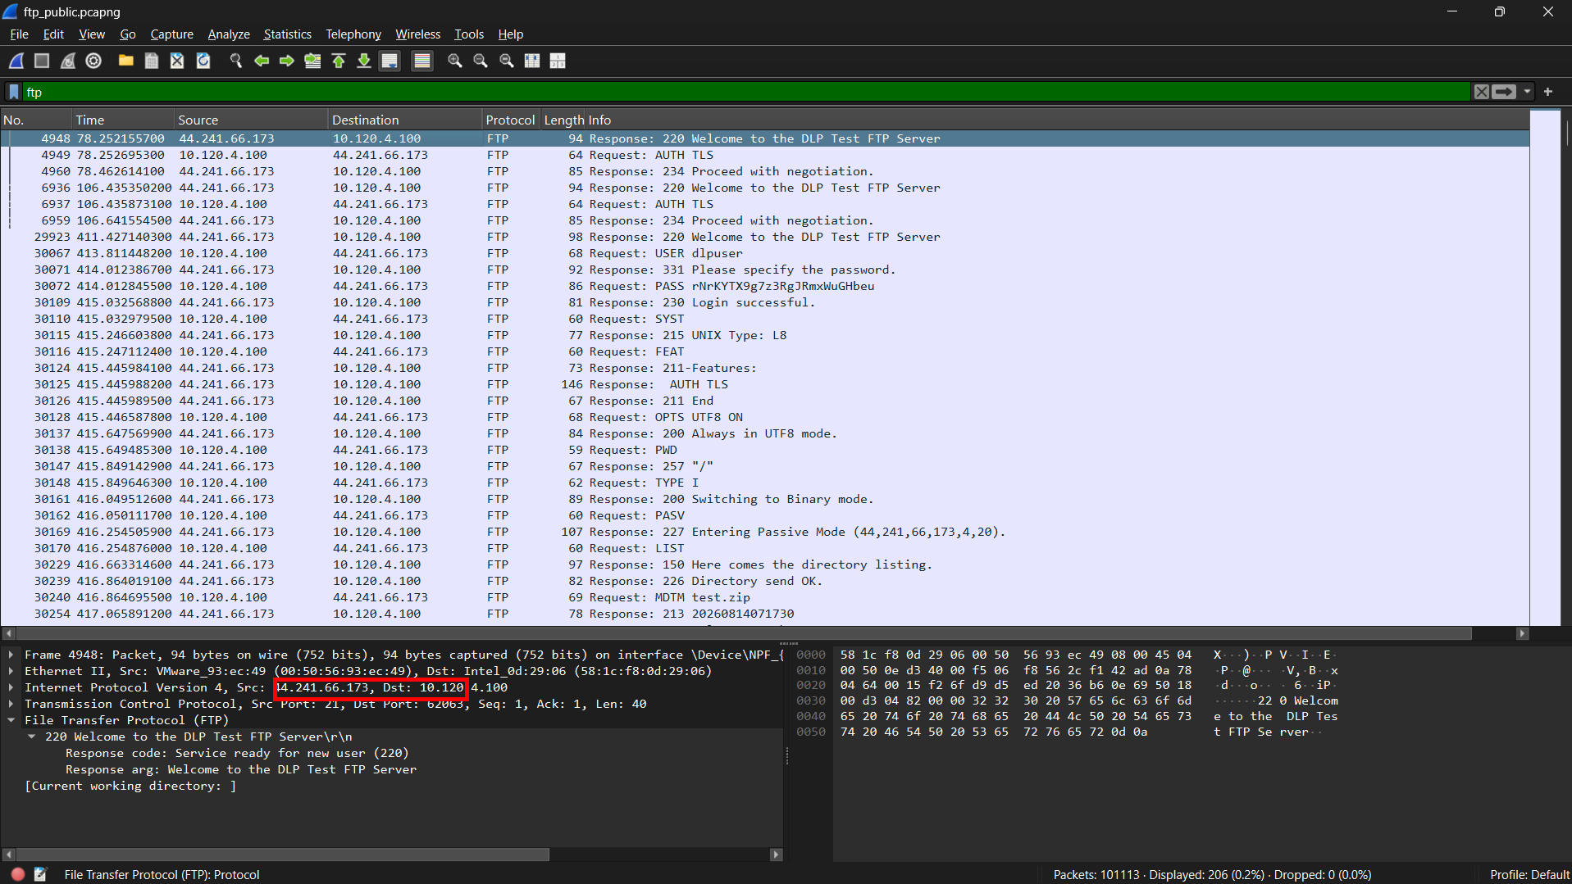

- Which packet establishes the connection?
- The FTP control connection is established through the TCP three-way handshake. Packet 92794 is the SYN, packet 92819 is the SYN-ACK, and packet 9282 is the final ACK/ Therefore, packet 92820 completes the connection establishment.
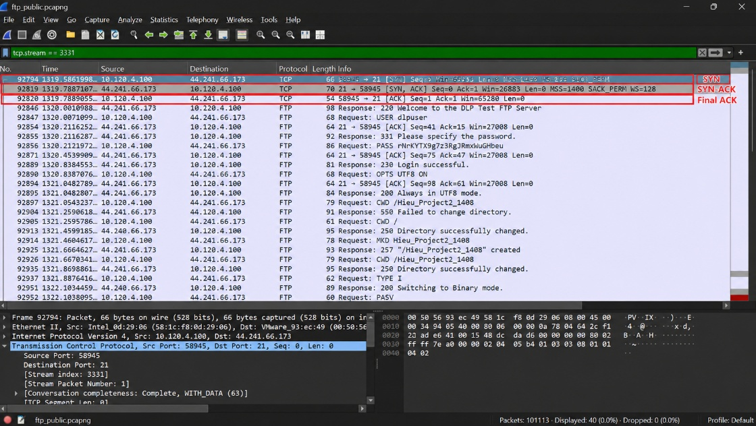
- What protocol appears before FTP?
- TCP appears before FTP. Before FTP messages can be exchanged, the TCP control connection must first be established through the three-way handshake.

Experiment 2 — Login Authentication (Step 3)
- Can the username be seen?
- Yes, the username can be seen in plaintext. Packet 92847 contains the FTP command USER dlpuser, showing that the username is transmitted without encryption.
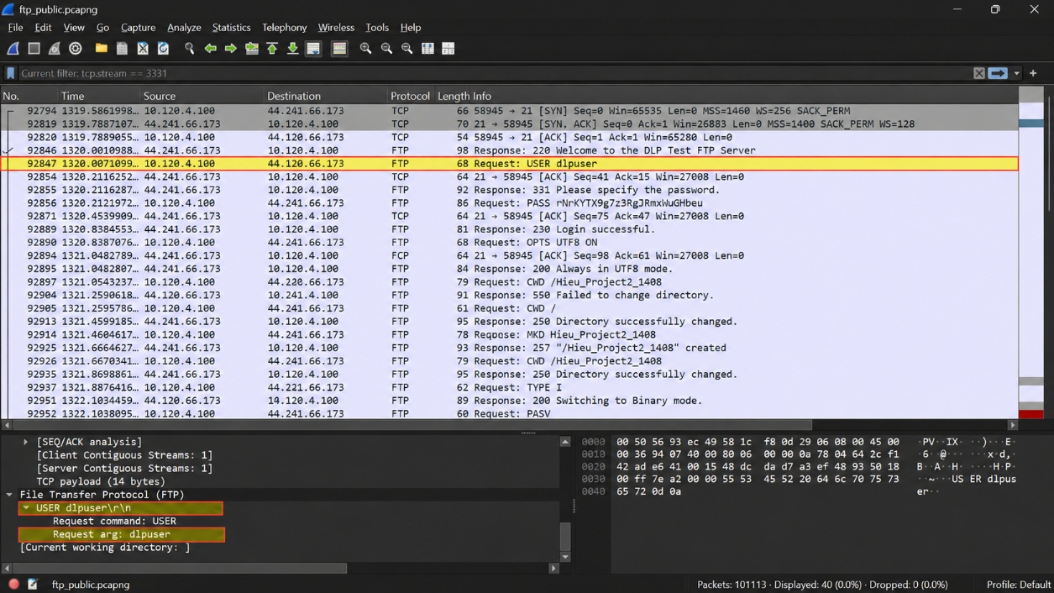
- Can the password be seen?
- Yes, the password can also be seen in plaintext. Packet 92856 contains the FTP command PASS rNrKYTX9g7z3RgJRmxWuGHbeu , which shows that the password is transmitted without encryption.
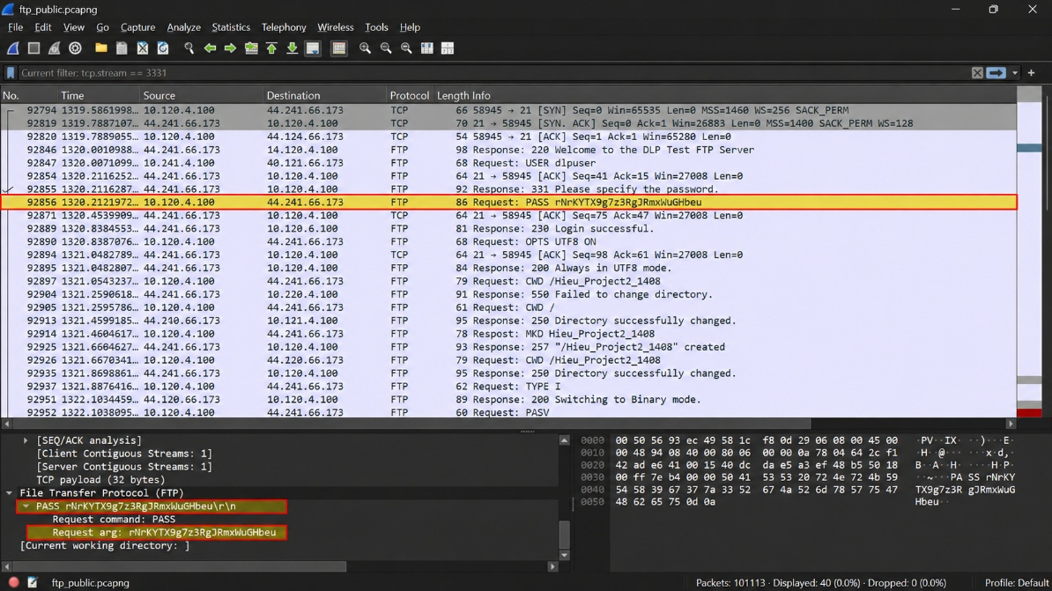

- Why is this dangerous?
- This is dangerous because FTP transmits the username and password in plaintext. Anyone who can capture the network traffic may read the credentials directly and use them to access the FTP server without authorization.

- Which server response indicates successful login?
- Packet 92889 contains the server response 230 Login successful, which indicates that the FTP authentication was completed successfully.

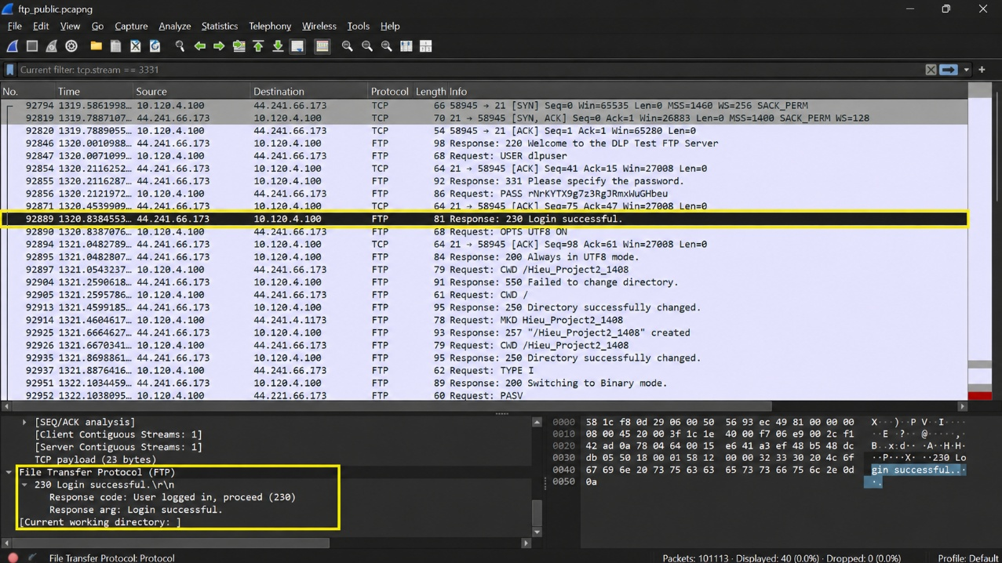
Experiment 3 — Directory Listing (Step 4)
- What command requests the directory?
- The LIST command requests the directory listing. In packet 93405, the client sends LIST -a to request the directory contents.
- Which port transfers the data?
- The directory listing data is transferred through TCP port 1111. Packet 89961 contains the passive-mode response 227 Entering Passive Mode (44, 241, 66, 173. 4. 87), giving the data port as 4 x 256 + 87 = 1111 . Packet 89963 also shows the client initiating a TCP connection to server to port 1111.
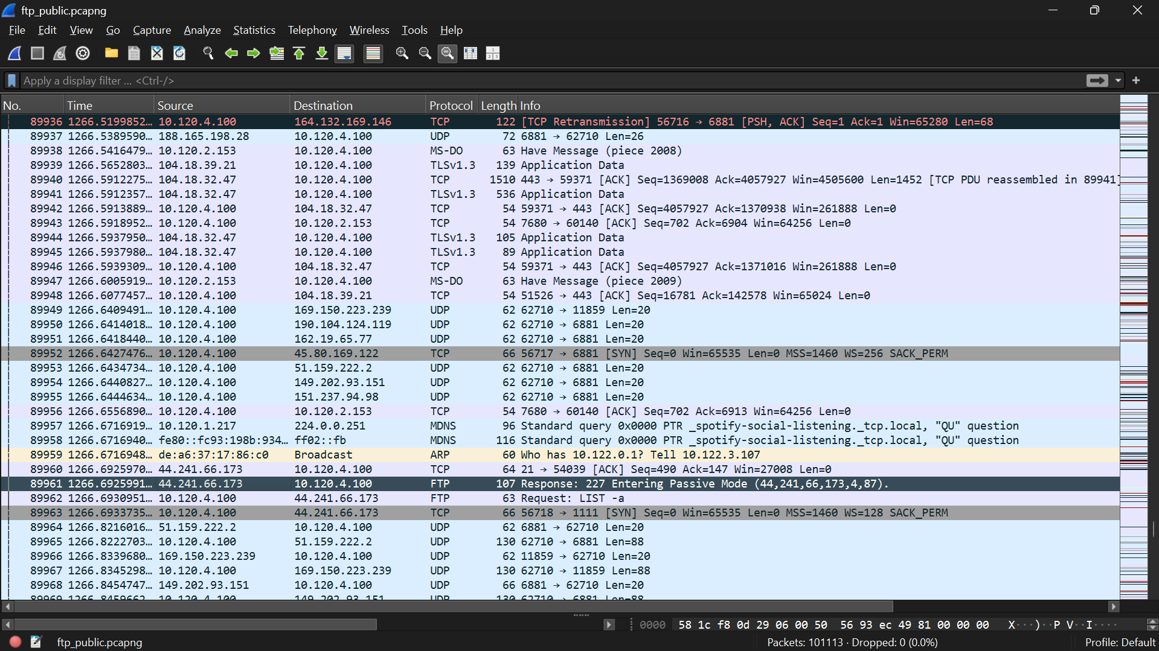
- Which TCP connection carries the directory listing?
- The directory listing uses a separate TCP data connection, TCP stream 3239, from client port 56718 to server port 1111.
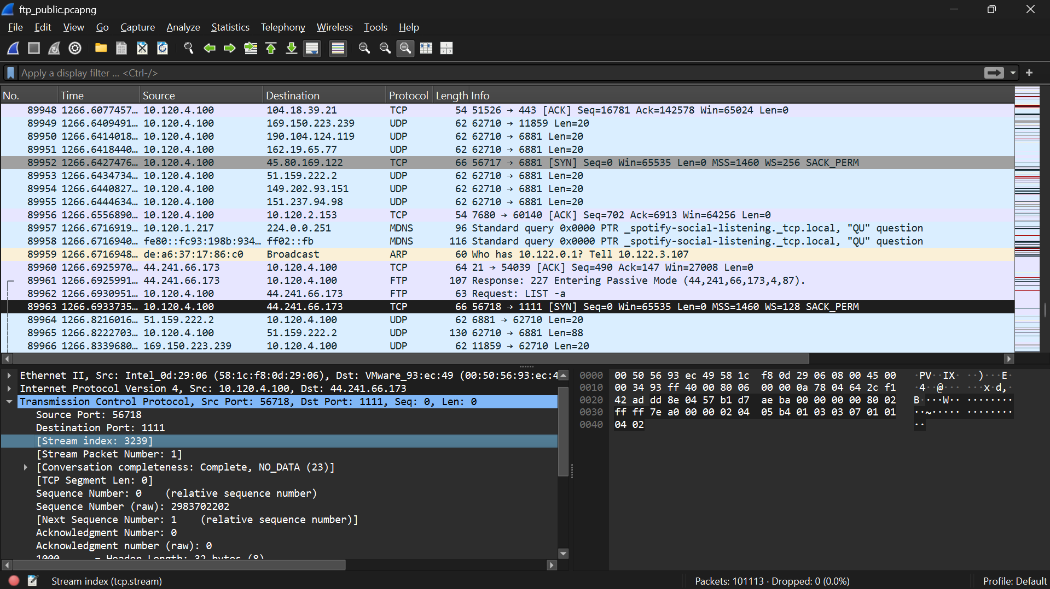
Experiment 4 — Upload a File (Step 5)
- Which command uploads a file?
- The STOR command is used to upload a file to the FTP server. In packet 92971, the client sends STOR Screenshot (25).png to begin the upload.
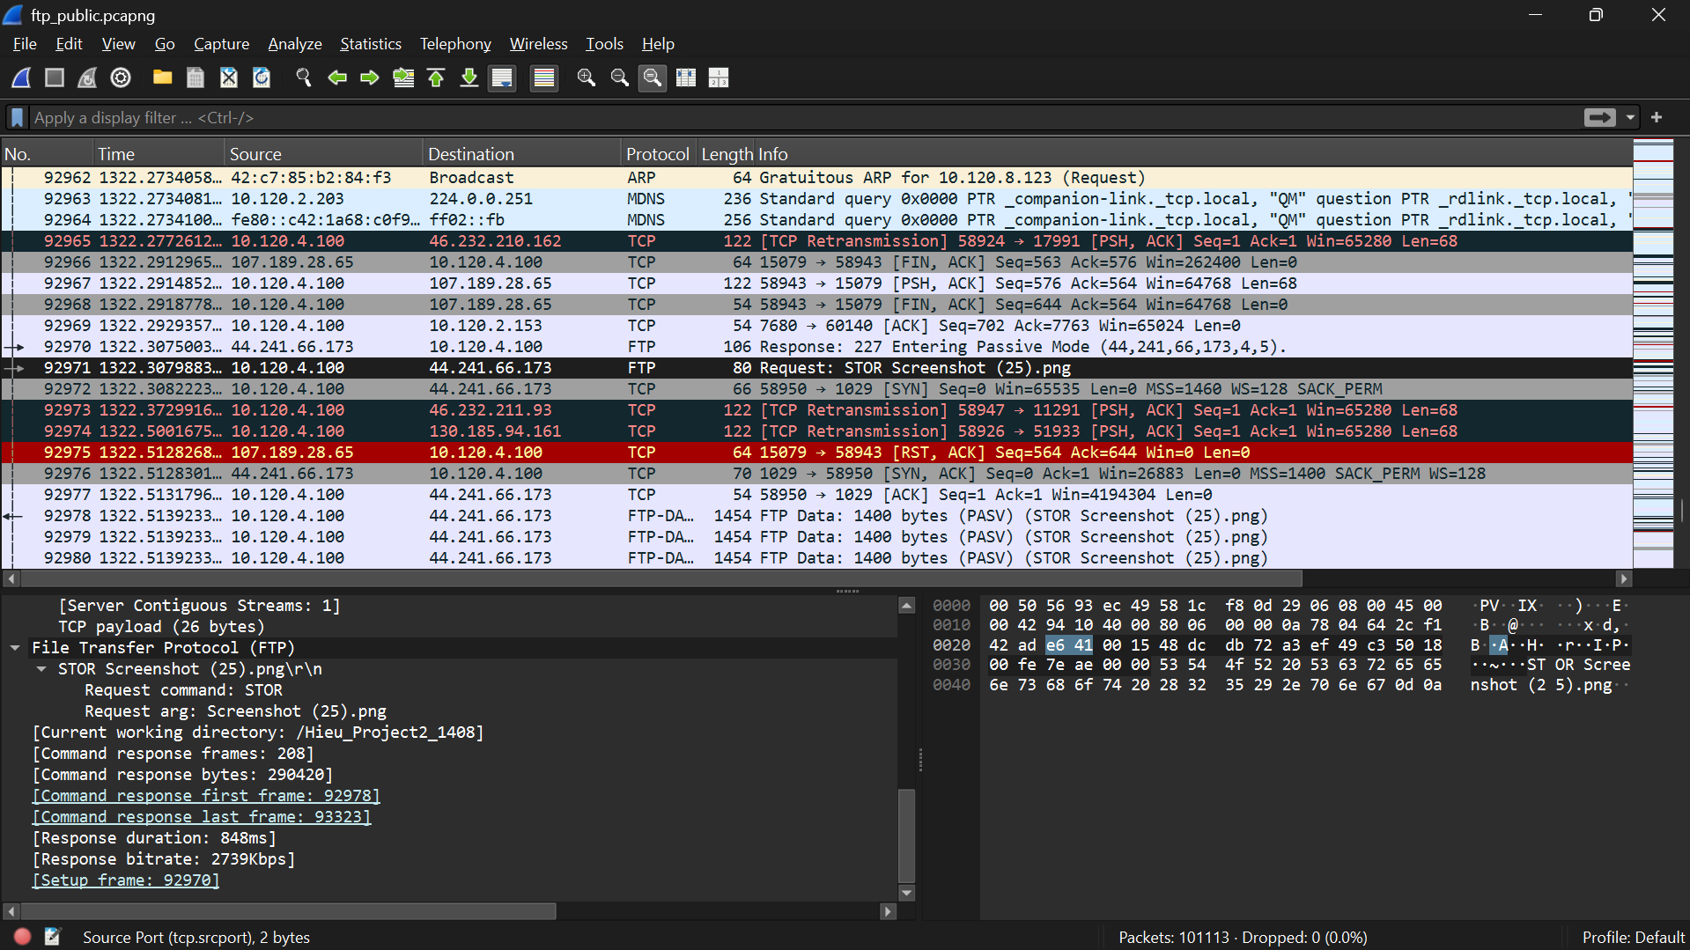
- Which data connection is used?
- The upload uses a separate passive-mode TCP data connection, TCP stream 3336, from client port 58950 to server port 1029. The server selected port 1029 through the PASV response.
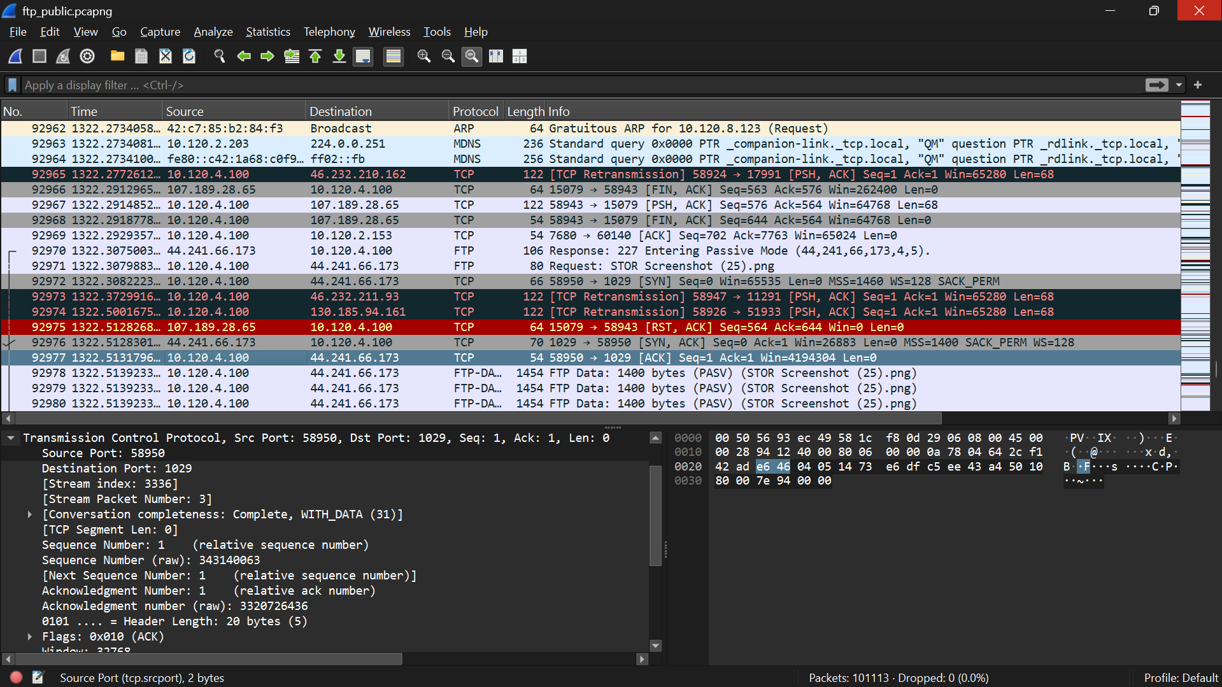
- What is the transfer duration?
- The upload transfer duration is approximately 0.847 seconds (847 ms), measured from the first FTP-DATA packet 92978 to the last FTP DATA pact 93323.
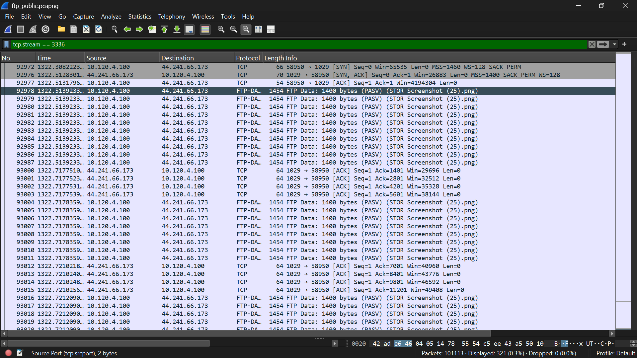
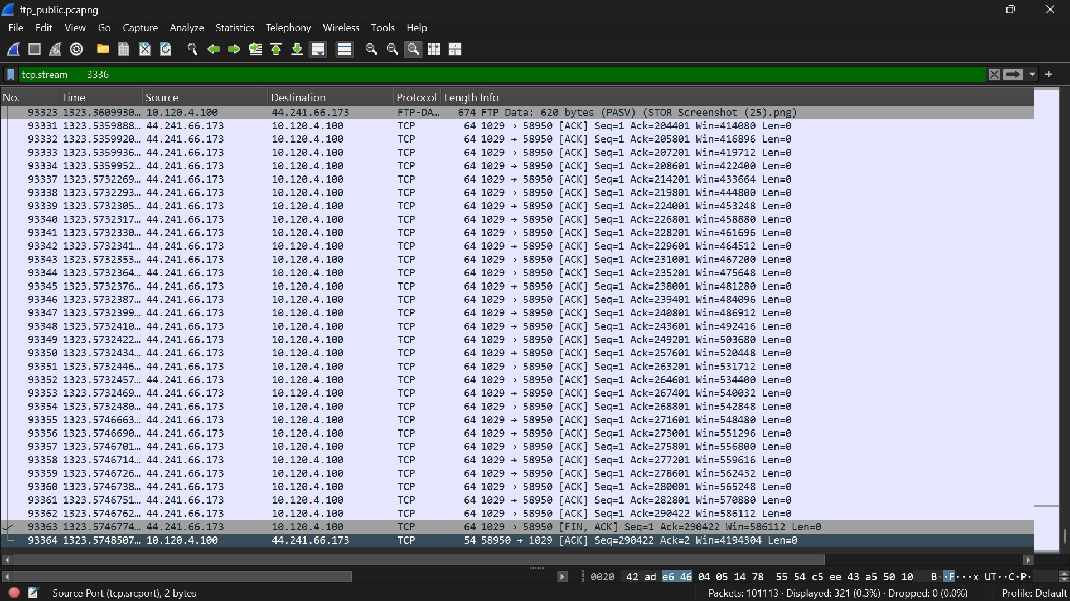
Experiment 5 — Download a File (Step 6)
- Which command downloads a file?
- The RETR command is used to download a file from the FTP server. In packet 94734, the client sends RETR Screenshot (25).png to request the file.
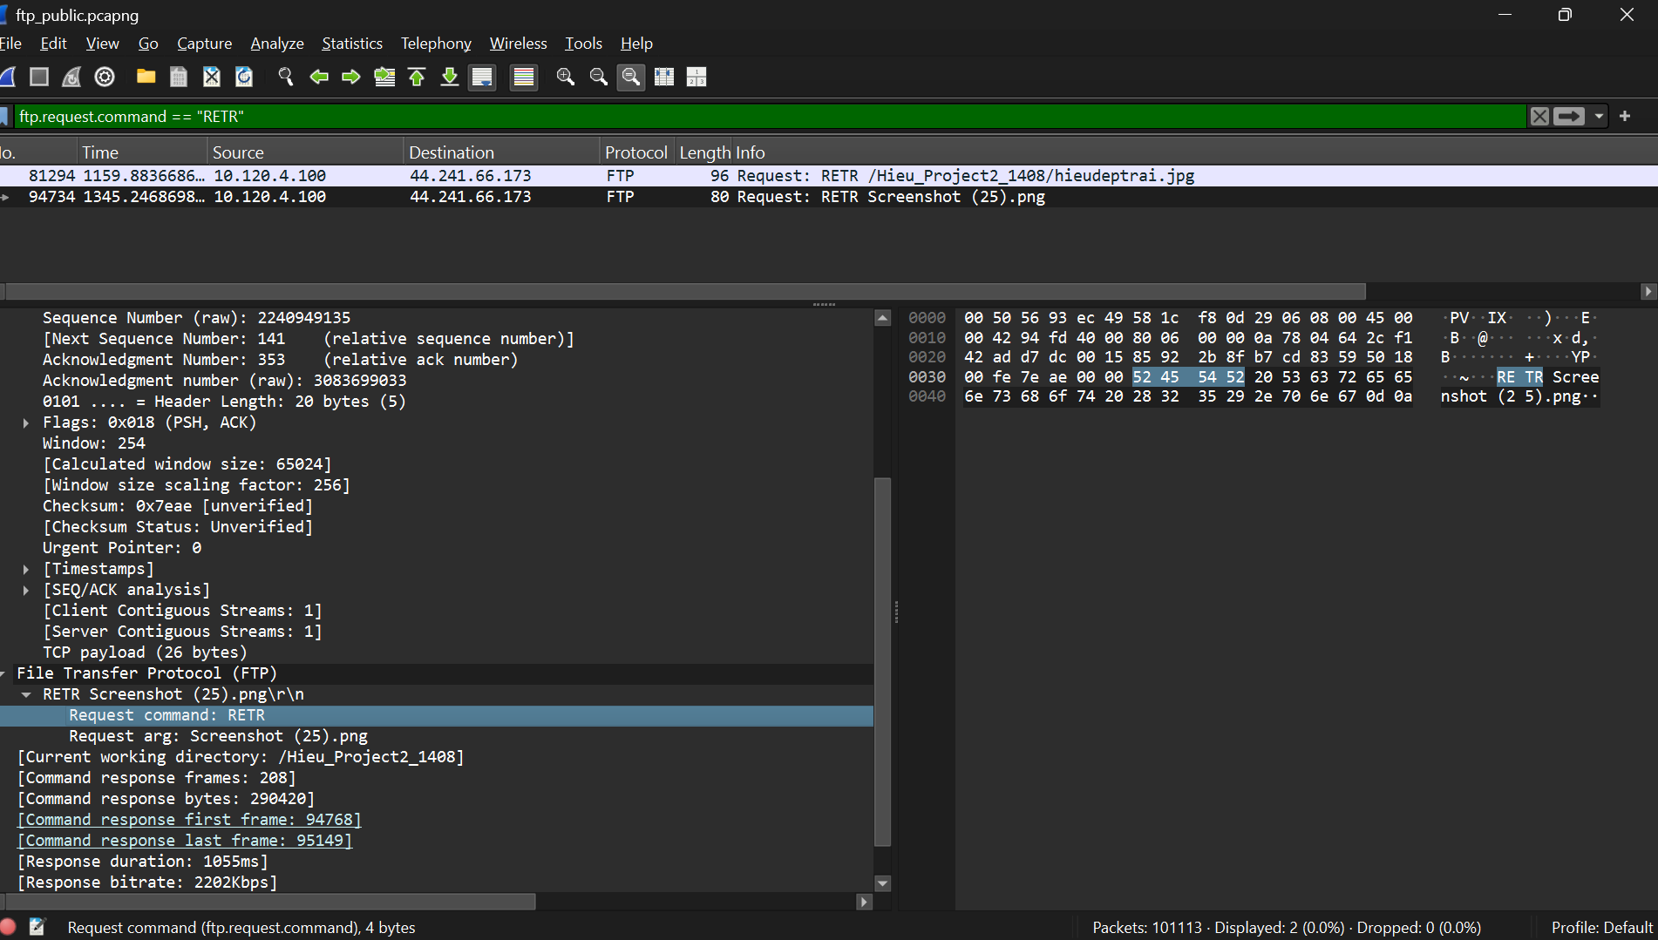
- How many packets were transferred?
- A total of 208 FTP-DATA packets were transferred during the download. This was determined by filtering TCP stream 3387 with ftp-data, where Wireshark displayed 208 packets.
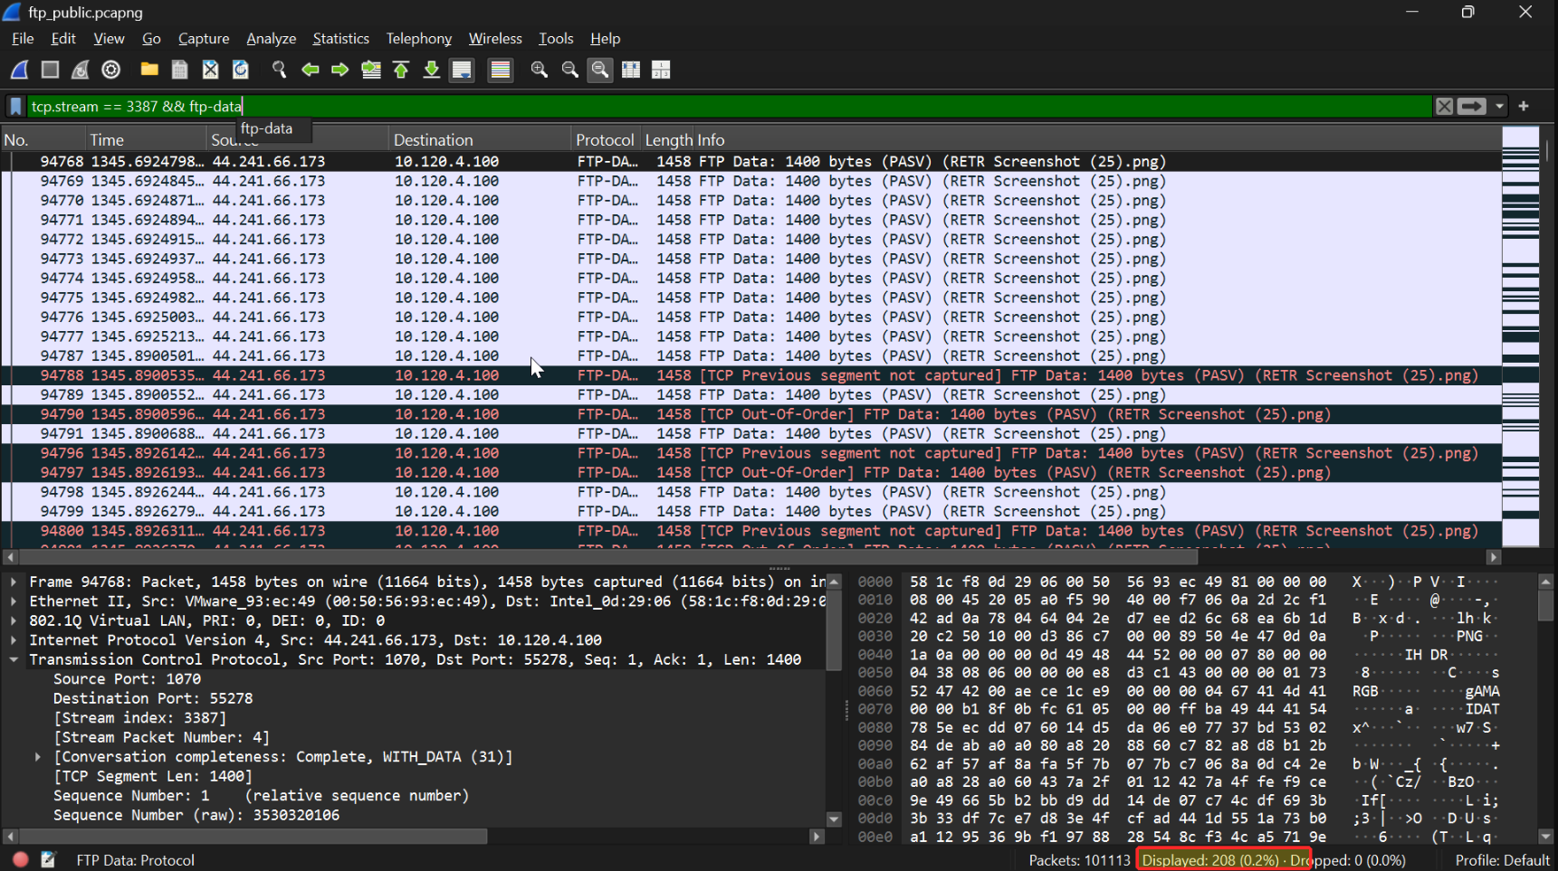

- What is the file size?
- The downloaded file size is 290,420 bytes. Wireshark reports Command response bytes: 290420 for the RETR Screenshot (25).png request.
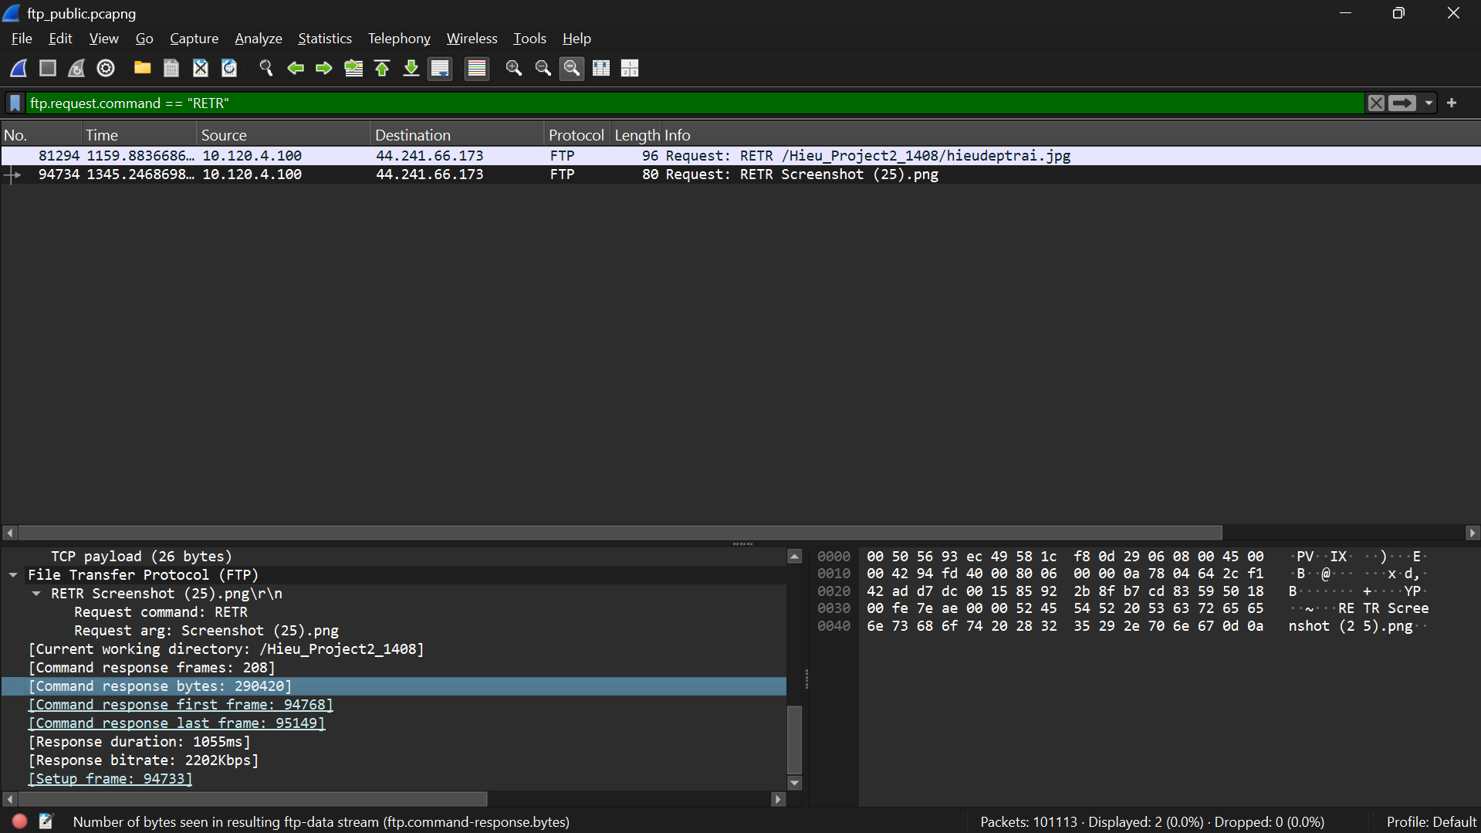
- Which TCP stream contains the file?
- The downloaded file is carried in TCP stream 3387. Wireshark shows Stream index: 3387 for the FTP-DATA packets of RETR Screenshot (25).png.
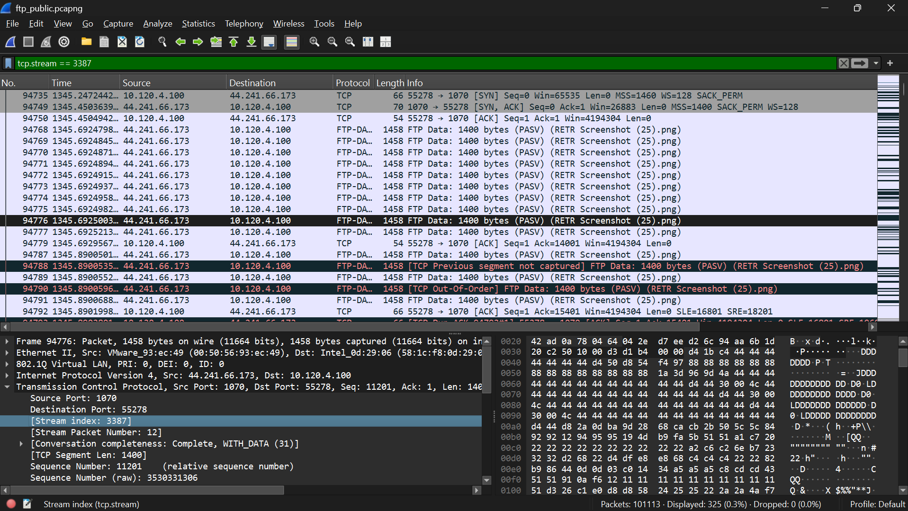
- Passive/Active Mode? Why?
Passive Mode is used. Packet 94733 contains the response 227 Entering Passive Mode (44,241,66,173,4,46). The client then initiates the data connection in packet 94735 from port 55278 to server port 1070.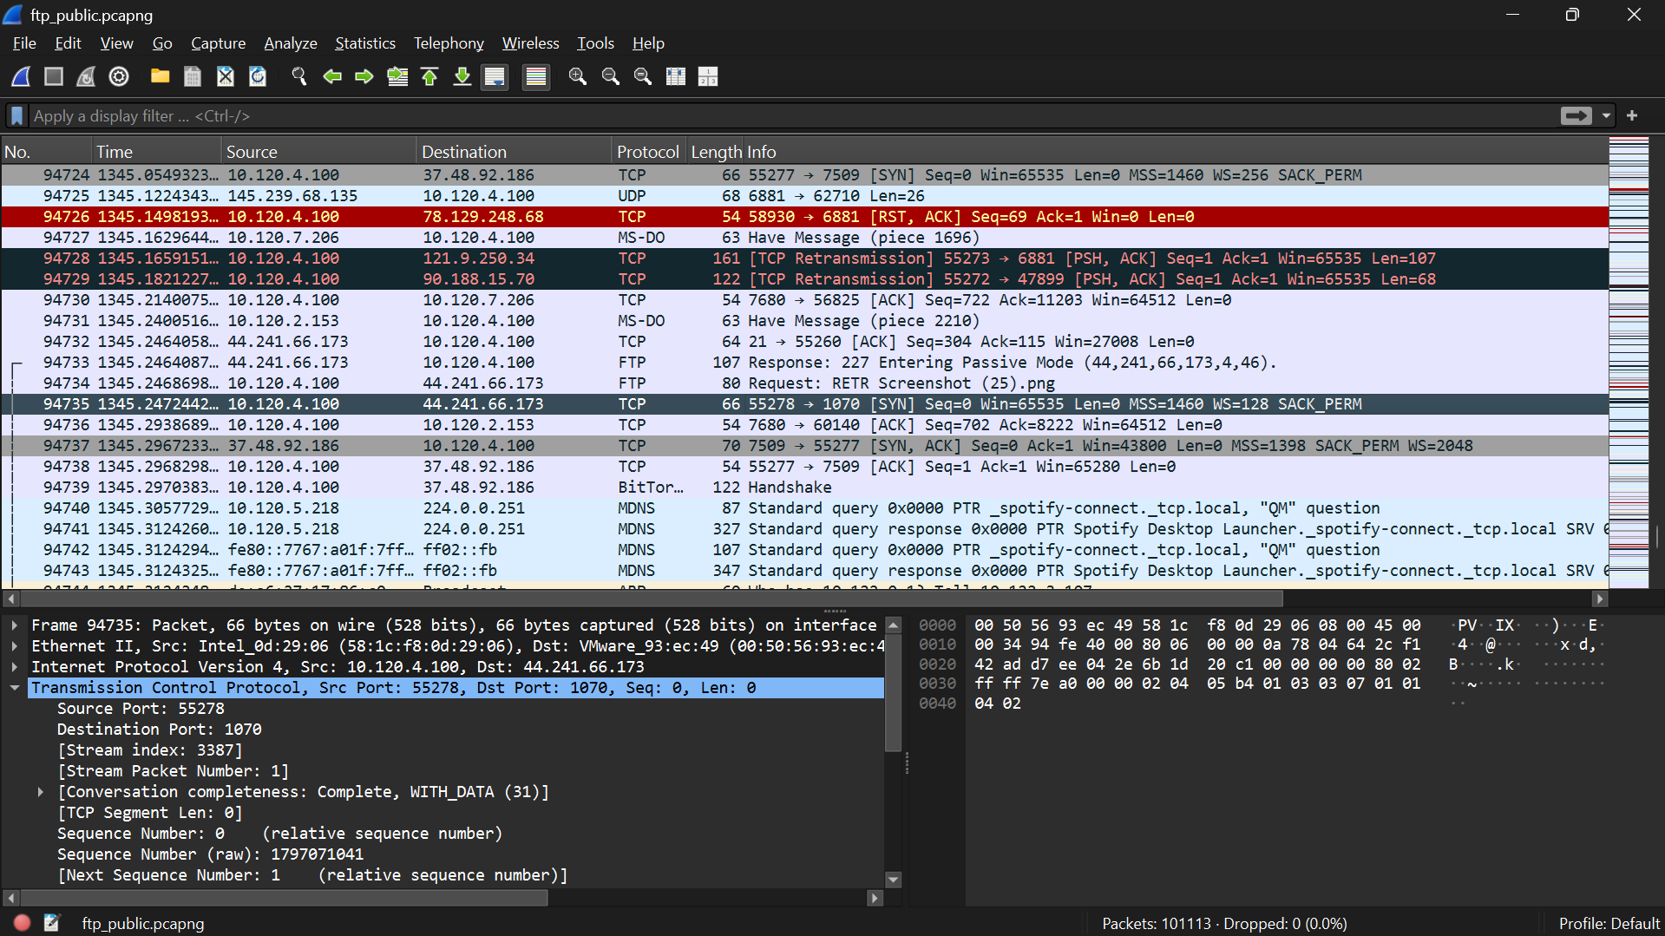
- Who initiates the data connection?
- The client initiates the data connection. In packet 94735, the client (10.120.4.100) sends the initial TCP SYN from port 55278 to the FTP server (44.241.66.173) on port 1070. This is consistent with FTP Passive Mode.


